Funding Source Report

April 2012

Funding Source Report for the Autism Society of Southeastern Wisconsin
Project: T.R.A.I.L.S., Transition for Raising Autism Independence and Living Skills

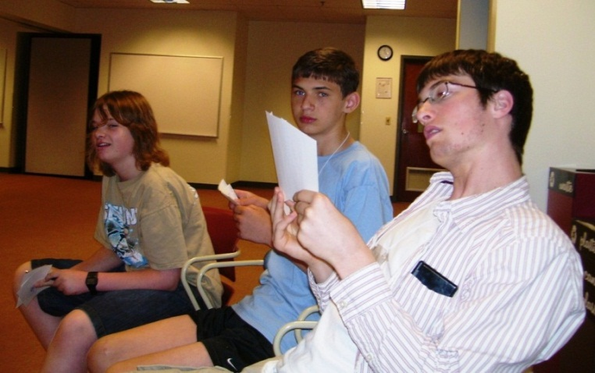
T.R.A.I.L.S. students 2010

This report contains summarized information for potential funders. The information includes:

- the grantmaker’s name and contact information
- preferred method of initial contact
- geographic focus
- grant size
- application guidelines
- suggested request amount
- recommended writing strategy and evidence for it

Material was gathered from electronic funding resources at Marquette University, namely Foundations in Wisconsin Online and the Foundation Directory Online, which is a national database of foundations. The National Center for Charitable Statistics provided 990 forms, which specified recent recipients and their grant amounts. Foundation websites were accessed when available.

Potential funders are listed according to likelihood of success in securing a grant. All included foundations are organizational funders. They do not fund individuals.

**** Best match
*** Good match
** Acceptable match
* Least likely match
-- Unlikely match
**** Daniel Jordan Fiddle Foundation, Inc.

Contact Information
Contact Person: Linda Walder Fiddle, President and Executive Director
Address: c/o Frederick Fiddle
P.O. Box 1149
Ridgewood, NJ 07451-1149
Phone: (201) 444-4141
Toll-free: (877) 444-1149
Email: info@djfiddlefoundation.org
Website: www.djfiddlefoundation.org

Preferred Method of Initial Contact
Letter of Inquiry

Note: Unsolicited proposals are not accepted in 2012, but this is a great match, so aim to cultivate a relationship with the funder for future funding periods.

Foundation Details
Programs should benefit adolescents and adults with autism. This foundation focuses on programs that could function as replicable models within communities throughout the nation and worldwide. The foundation’s mission is to develop, advocate for, and award grants to programs that create innovative ways for adults with ASD to participate in and contribute to community life. The foundation provides grants specifically geared to programs that enhance the lives of young adults transitioning to adult life and adults living with autism.

Geographic Focus
Recipients can reside in the United States and abroad.

Grant Size
Average and median grant size is approximately $2000. Most grants given are greater than $2000. However, a few grants are less than $1000.

Application Guidelines
Application guidelines will be available on the website when unsolicited proposals are accepted. The grant deadline is November 1 of the year prior to the grant year. Final notification is February 1 of the grant year.

Request Amount
With no prior relationship to the funder, but considering the total grants given equals $148,170 and the average grant size is $2000, the recommended request amount is $2000.

Recommended Writing Strategy
Logic as a writing strategy is recommended. Because this foundation resembles ASSEW in style and tone, they are familiar with the emotional appeal that coincides with ASD. National competition for funding is fierce, so the strength of T.R.A.I.L.S. as a transition program must show through in the facts. For example, provide details about how many families will be helped, what topics will be covered, and how success will be measured. Include information that sets T.R.A.I.L.S. apart, such as its potential as a model for other communities.

*** Jerome J. & Dorothy H. Holz Family Foundation

Contact Information
Contact Person: Donald Tushaus (title unknown)
Address:
10400 Innovation Drive Suite 110
Milwaukee, WI 53226
Phone: (414) 774-1031
Email: Not available
Website: Not available

Preferred Method of Initial Contact
Letter of Intent

Foundation Details
This foundation focuses on children and youth services, community improvement and economic development, and the disabled. The foundation gives priority to programs that benefit the education of youth and child development and the special education of handicapped individuals. Proposals should focus on education and community support.

Geographic Focus
Priority is given to the greater Milwaukee metro area.

Grant Size
Grants range from $2000 – $170,000, while the median grant size is $5000.

Application Guidelines
The application process starts with a Letter of Intent. Once the Letter of Intent is received, the foundation will provide a grant application and brochure with guidelines. The grant application is a two-page financial questionnaire. The program and purpose for the grant must be described in 100 words. The application does not include a narrative portion. Application procedures are found in the foundation’s 990 form. The deadline for a completed grant proposal is May 1. Grant checks are awarded in August. Grantees must report the program results within one year and interim reports are suggested.

Address all requests to: Jerome J. Holz, President
Jerome J. and Dorothy H. Holz Family Foundation
c/o Don Tushaus

Request Amount
Based on the type of awards given to similar programs and the median grant size, the recommended request amount is $4000, slightly less than the median amount.

Recommended Writing Strategy
An emotional approach in the Letter of Intent, showing the importance of autism and how it affects the community, is recommended. The application requests all the hard data, so a logical approach is inclusive of the application. Since space is limited in the application to convey a message, an emotional appeal in the application message will make a strong impact with few words and complement all the logical information. The foundation already supports the disabled, but the case needs to be made for this program that focuses on autism. Include statistics on autistic students not graduating from high school and emphasize that all students should reach this milestone.

** Gardner Foundation

Contact Information
Contact Person: Theodore Friedlander, III, Vice-President
Address:
322 E. Michigan St. Suite 250
Milwaukee, WI 53202-5010
Phone: (414) 273-0308
Email: Not available
Website: Not available

Preferred Method of Initial Contact
Letter of Intent, requesting guidelines and application

Foundation Details
This foundation focuses on children and youth services, community improvement and economic development, crime and justice, and the disabled. The foundation supports social welfare, arts, education, and health projects. It encourages grant requests from small, new, or emerging organizations and for new, innovative projects.

Geographic Focus
The geographic limits are the greater Milwaukee area.

Grant Size
Grants range from $500 – $7000, while the median grant size is $2000.

Application Guidelines
The foundation does accept the Donors Forum of Wisconsin Common Application Form. Guidelines and application must be requested by letter. The Spring deadline is April 15 and the Fall deadline is October 15.

Request Amount
Based on no prior relationship with the funder and the median grant amount of $2000, as well as the types of awards given to similar programs, the recommended request amount is only $1000.

Recommended Writing Strategy
A writing strategy combining logic and emotion is recommended because the foundation does not provide much data about itself. Additionally, disabled ranks fourth in the foundation’s subject focus, so it is imperative that the foundation understands why this program and autism support are worth its investment. Incorporate statistics and testimonials to present a broad spectrum of information about ASSEW and autism in general. Statistics should include the unemployment rate for the disabled and how many autistic students don’t graduate high school. Testimonials from previous students about how T.R.A.I.L.S. impacted their lives will show the human factor. Mention how many families will be affected by the program and how success will be measured.

** Dorothy Watkins Inbusch Foundation

Contact Information
Contact Person: Thomas J. Drought (title unknown)
Address: c/o Cook and Franke S.C.
660 E. Mason St.
Milwaukee, WI 53202-3877
Phone: (414) 227-1213
Email: Not available
Website: Not available

Preferred Method of Initial Contact
Not specified. Letter of Intent is recommended.

Foundation Details
This foundation focuses on children and youth services, community improvement and economic development, and the disabled.

Geographic Focus
Geographic limits are not specified.

Grant Size
Grants range from $500 – $15,000, while the median grant size is $3000.

Application Guidelines
The foundation does accept the Donors Forum of Wisconsin Common Application Form. Contact the foundation for application materials and guidelines. The deadline for grant submission is October 31.

Request Amount
Since there is no relationship with the funder, and based on the median grant size and types of awards given to similar programs, the recommended request amount is $1500.

Recommended Writing Strategy
A writing strategy combining logic and emotion is recommended because the foundation does not provide much data about itself. Incorporate statistics and testimonials to present a broad spectrum of information about ASSEW. Statistics should include the unemployment rate for the disabled and how many autistic students don’t graduate high school. Testimonials from previous students about how T.R.A.I.L.S. impacted their lives will show the human factor. Mention how many families will be affected by the program and how success will be measured.

Less Likely Matches

* John and Ruth Kloss Charitable Trust

This foundation focuses on children and youth services, as well as boys and male youth. However, the subject focus does not include the disabled, the geographic area is limited to Kenosha County, and the recipients are not similar enough to warrant a higher ranking. For example, there are not many children’s or educational recipients and no recipients for disorders or the disabled.

* Washington Capitals Charities

While this charity does give on a national basis, the majority of its grants are awarded to Washington, D.C. organizations. The likelihood of grant success is diminished when only one out-of-state grant is awarded per year. However, they do support autism and other developmental disorders.

-- Autism Speaks

Although its focus is entirely on autism, the foundation focuses on research, rather than program development grants.

-- Lili Claire Foundation, Inc.

This foundation’s first priority is autism, along with other genetic diseases and disorders. At first, it seems like a great match. However, in the past year, it has only awarded money to a medical school and one small foundation in its vicinity. There are no instructions for the grant process, no grant range, or any other grant information to provide evidence that it regularly awards grants to organizations. If this foundation starts awarding more grants on a national basis, upgrade to a great match and cultivate a relationship.

