

9733 W. St. Martins Road, Franklin, Wisconsin 53132
Telephone: 414-427-9345
Website: www.assew.org
Contact: Emily Levine at emily@assew.org

Mission Statement
We support people with autism spectrum disorders, their families, professionals, and others, by sharing information, supporting research, providing networking opportunities, and promoting awareness through education and training.

Goals
- Increase public awareness about day-to-day issues faced by people on the spectrum.
- Advocate for appropriate services for individuals across their lifespan.
- Provide the latest information regarding treatment, education, research, and advocacy.

Objectives
- Information and referral to parents, professionals, and the public
- Workshops, presentations, and parent-to-parent forums
- Monthly support groups
- Community outreach and networking opportunities

History
The Autism Society of Southeastern Wisconsin received its chapter status from the National Autism Society in 1976. For over 30 years, we have served as the primary Autism/Asperger Syndrome/PDD resource for Milwaukee, Waukesha, Racine, Kenosha, Dodge, Jefferson, Ozaukee, Walworth, and Washington counties.

Accomplishments
- The TRAILS program has taught 350 parents and children how to prepare for their futures since 2010.
- “Lose the Training Wheels”™, a collaborative program with the Down Syndrome Association of Wisconsin, has helped almost 200 children learn to ride a bike since 2006.
- The Parenting Series serves 200 parents each year.

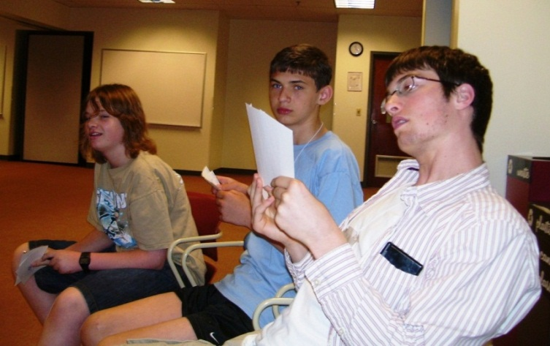
TRAILS session 2010

Programs and Services
- T.R.A.I.L.S., “Transition for Raising Autism Independence and Living Skills”, is a four-part series of workshops for parents of 14-21 year-olds on planning for the transition to adulthood.
- “Lose the Training Wheels” ™ bike program teaches children with autism and other special needs to ride a bicycle independently.
- “Sibshops”™ provide the opportunity for brothers and sisters of children with autism and other special needs to get together for support and education in a recreational setting.
- “Sensory Friendly Films” ™ allow children with autism spectrum disorders and their families to see family movies in an environment sensitive to sensory needs.
- Parent workshops and teacher training
- Monthly “Adults On the Spectrum” support group
- Monthly, from September to June, “Morning Coffee Parent” support group

Staff and Board of Directors
- Executive Director: Emily Levine
- Information and Communication Specialist: Julie Quigley
- Fund Development Manager: Renee Logee
- Development Associate: Rebecca Doherty
- Administrative Coordinator: Sue Skaufle
- 13 directors on the board
- 200 – 300 volunteers help with projects throughout the year.

Financials

